|  |
| --- |
| **STUDENT NAME** |
| Alley Chaggar |

**LAB #11**

BEFORE WE START 2

ACTIVITY 1 2

ACTIVITY 2 5

# BEFORE WE START

1. Double – click on the Blender icon on your desktop.
2. Close the tutorials windows.
3. Start rendering.

# ACTIVITY 1

**BLENDER BASICS AND TRANSFORMATIONS**

Blender as a rendering tool provides us with tool for moving, rotating and scaling the objects. We can also create, modify, and delete the objects in our projects. This tutorial demonstrates how to use these tools and how to add and modify objects.

Follow the steps below:

1. Click on the Cube in the middle of the screen and select it.
2. Press the Delete button on your keyboard, removing this object.
3. Click on the Layout menu (top).

4.

Click Mesh

→

Plane, as shown below:

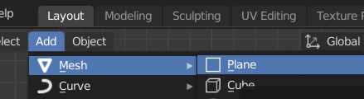

1. Click on the Plane and then click on the Scale tool (left sidebar).
2. Click on the Move tool.
3. Place the Plane at the center of the X and Y axes using the move handles.
4. Increase the size to cover 20 units (small squares).
5. Click Mesh → Torus.

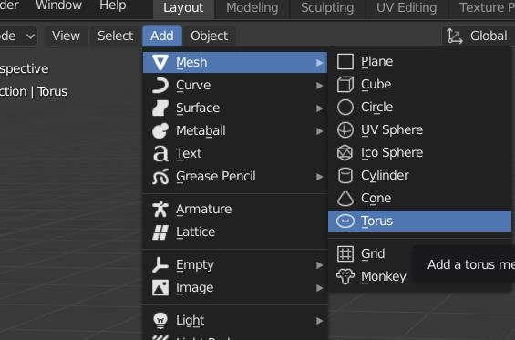

1. Click on Add Torus option right next to the new object.
2. Set the Major Radius to 0.05m and the Minor to approx. 0.03m.



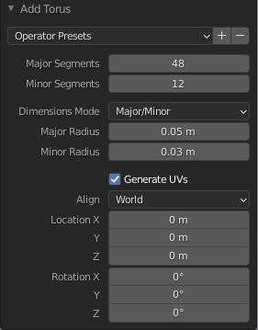

1. Click and press the middle mouse button and rotate around to see the result.
2. Set the Major Segments options (Add Torus menu) to around 30 and the Minor to 12.
3. Click on the Scene tab under the Panels (right column) and set the Units System to Metric (if any other is selected).

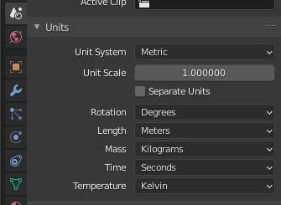

1. Click on the Torus again and in the Panel, under the Object tab, set its location to the intersection of axes X and Y (move it over the Plane if needed).
2. Set the Rotation X to 12o, Y to 3 and Z to 4.
3. Set the Scale X, Y and Z to 1.5.
4. Click on the Y axis gizmo, as shown below:

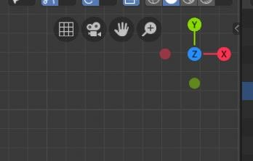

1. Re-position the camera using the middle mouse button, looking the torus from above.

|  |
| --- |
| **TASK 1.1:**  Take a screenshot of the torus (and the whole screen) and paste it below: |
|  |

# ACTIVITY 2

**INTRO TO THE EDIT MODE AND MODIFIERS**

In Edit Mode we can modify the properties and outlook of any object. This tutorial demonstrates how to modify the basic properties of a simple object in Edit Mode.

Follow the steps below:

1. Click on the Torus.
2. Click on the Object Mode and at the drop-down menu select Edit Mode.

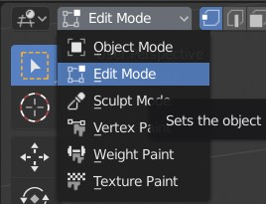

1. Click on the Proportional Editing button.

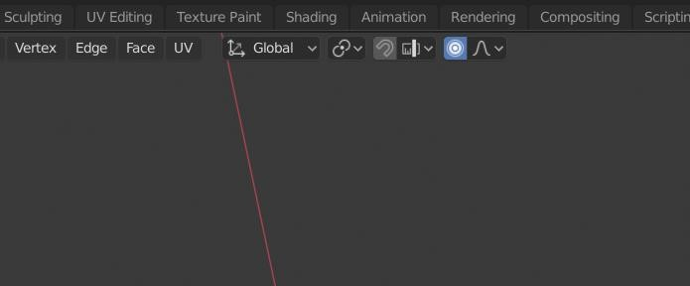

1. Click on any of the Vertices and press the key G on your keyboard.

1. Then, use the middle mouse button and create some irregularities on the Torus’ shape, as shown below:

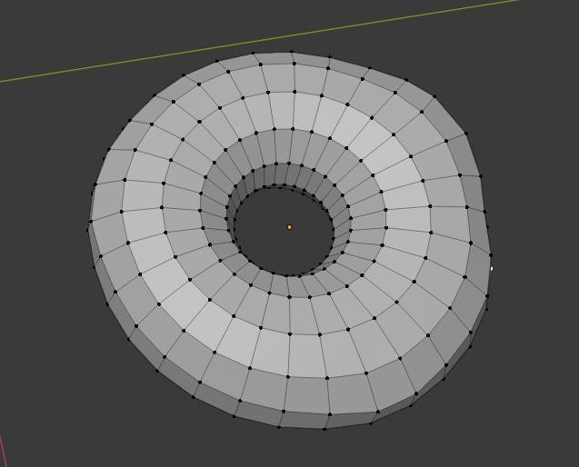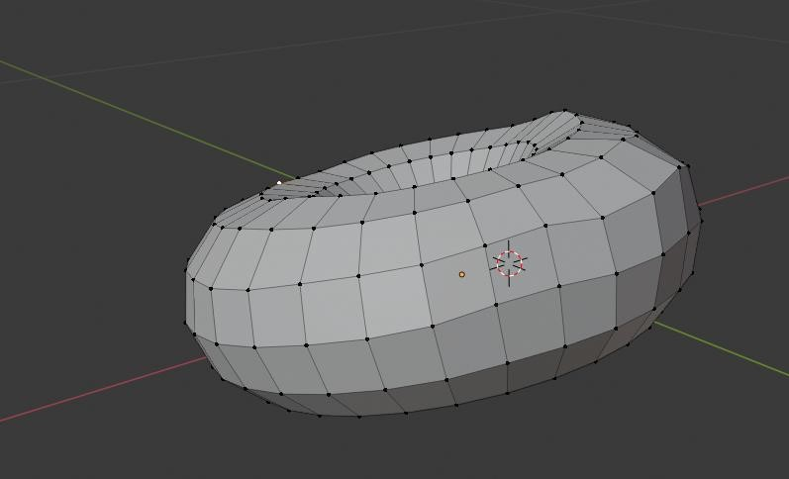

1. Return to the Object Mode.
2. Right – Click on the Torus and Select Shade Smooth.
3. Click on the Modifier under the Properties panel.
4. Click Add Modifier.
5. Select the Subdivision Surface.
6. Set the settings as shown below:

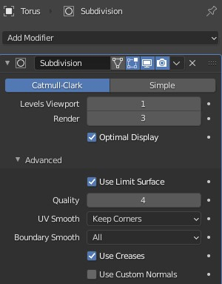

**TASK 2.1:**

Take a screenshot of the torus and paste it below:

|  |
| --- |
|  |

|  |
| --- |
| **TASK 2.2:**  What does it look like? Answer the question in the cell below. |
| It looks like a donut that is smooth. It doesn’t have icing either |

1. Click on the Torus and press 1 at the keypad (not the top 1-0 row) and then 3 at the keypad. – Did not understand……
2. Move the object to the center of the X and Y axes.
3. Click on the Object Mode and select Edit Mode.
4. Click on the Show X-Ray button (top – right), as shown below:

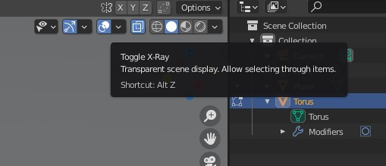

1. Click on the Select Tool, under the sidebar and select the top Torus area, as shown below:

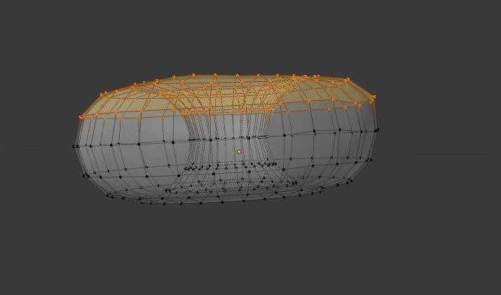

1. Expand the Mesh menu and select Duplicate, as shown below:

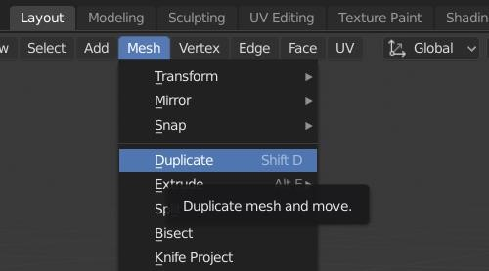

1. Select all the duplicated area and move it on top of the Torus.
2. Press P on your keyboard and then select Selection.
3. Return to Object Mode.
4. Under the Scene Selection menu, you should see two different Torus(es).

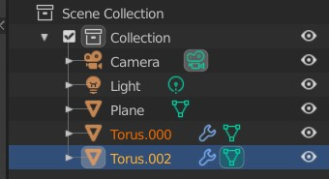

1. Double – click on the upper Torus and rename it to Icing.
2. Double – click on the lower Torus and rename it to Donut.
3. Return to Edit Mode.
4. Select the Icing and then click on the Move tool.
5. Move the Icing on top of the Donut.
6. Scale if needed to match the top of the Donut.

Once you complete the previous steps:

|  |
| --- |
| **TASK 2.3:**  Take a screenshot of the donut with the icing and paste it below: |
|  |

1. Click on the Icing.
2. Expand the View panel, as shown below:

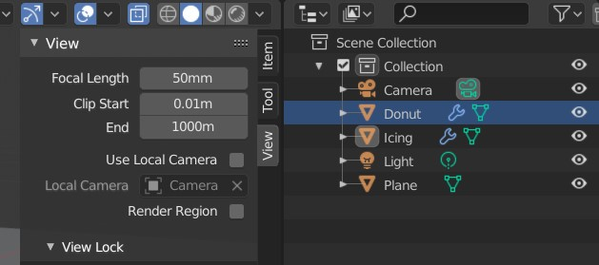

1. Set the Clip Start to 0.0001.
2. Click on the Modifiers button.
3. Click Add Modifier.
4. Select Solidify.
5. Set the Thickness to 0.0003.
6. Check if the donut looks like this:

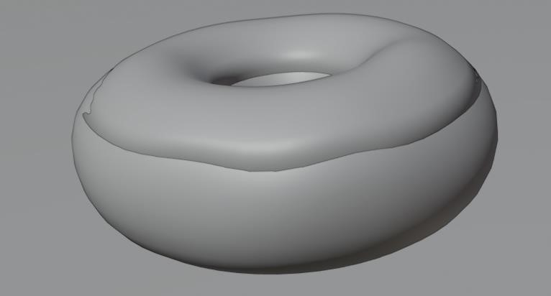

1. Click File → Save as…
2. Save the project as Donut.blend.
3. Click File → Export → FBX (.fbx).
4. Name the FBX file, Donut.fbx

|  |
| --- |
| **TASK 2.4:**  Locate the Donut.fbx file and add it to the submission folder. |
| In the LMS, add the file to the assignment Lab #11 submission folder. You can submit multiple files at a time. |

FINAL STEP: Save this document as a PDF. Upload the PDF to the Lab #11 submission folder.